Sales Performance Analysis Report (5-Year)

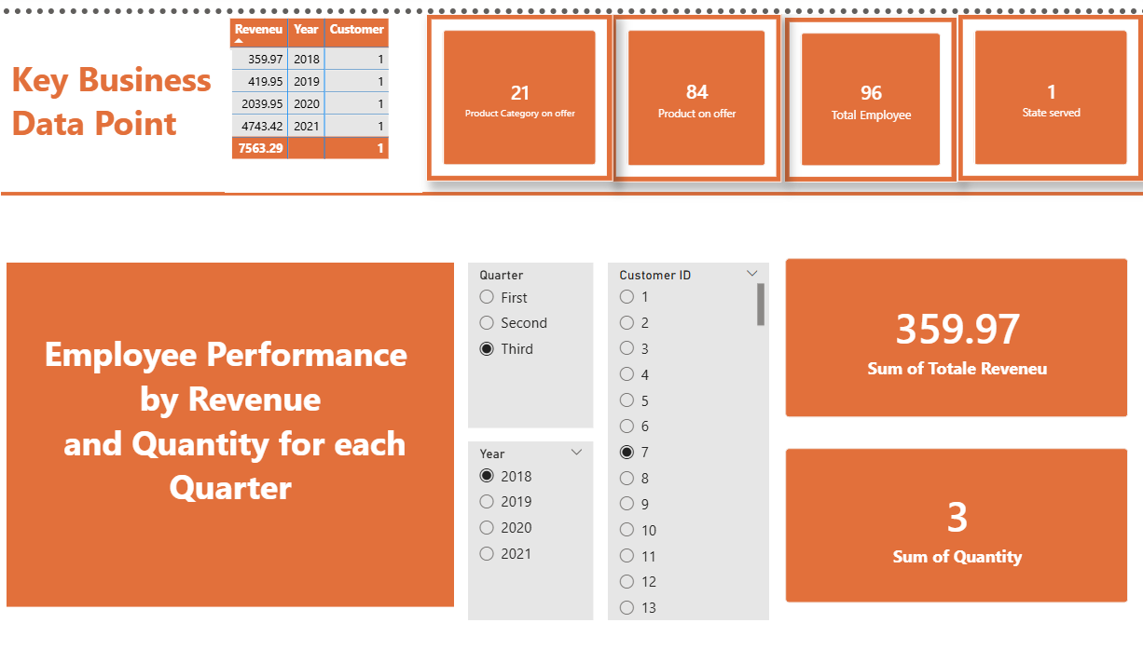
1. Project Overview
This project presents a comprehensive analysis of organisational sales data over a five-year period. The objective of the report is to evaluate business performance, identify trends and patterns, and provide actionable insights through interactive Power BI visualisations. The report is structured to align with the client’s stated requirements and mirrors the narrative style of a professional analytics case study.
The analysis focuses on revenue, customers, products, employees, and geographic performance, with a strong emphasis on year-on-year and quarter-based comparisons.

2. Business Objectives
The primary objectives of this analysis are to:
- Evaluate overall business growth over a five-year period
- Understand revenue and customer trends by year and quarter
- Identify top and bottom performing products, categories, employees, and states
- Assess employee sales performance based on quantity sold and earnings after discount
- Enable users to interact with the data and ask ad-hoc questions

3. Data Summary
The dataset used for this analysis spans five consecutive years and includes sales, product, customer, employee, and geographic data. Key data attributes include:
- Transaction dates (year and quarter)
- Revenue and earnings after discount
- Product names and categories
- Customer identifiers
- Employee sales records
- States served
Data preparation involved cleaning missing values, validating date fields, and ensuring consistency across product and employee dimensions to support accurate time-based analysis.

4. High-Level Performance Indicators
The dashboard provides a high-level snapshot of organisational performance through the following indicators:
- Total Revenue by Year showing overall financial growth and fluctuations
- Total Number of Customers by Year highlighting customer acquisition and retention trends
- Total Employees representing organisational sales capacity
- Total States Served reflecting geographic reach
- Total Products on Offer and Total Product Categories indicating portfolio breadth
These KPIs allow stakeholders to quickly assess scale, growth, and business complexity.

5. Revenue Analysis

5.1 Total Revenue by Year
The yearly revenue visualisation demonstrates how the business has performed over the five-year period. Clear year-on-year changes highlight growth phases as well as any periods of slowdown. This supports strategic evaluation of long-term performance.

5.2 Revenue by Quarter
Quarterly revenue analysis identifies seasonality and demand concentration. Certain quarters consistently outperform others, indicating potential seasonal sales patterns. These insights can inform forecasting, inventory planning, and marketing strategies.

6. Product Performance Analysis

6.1 Top and Bottom 5 Products by Year
The analysis highlights the top five and bottom five products for each year based on revenue contribution. High-performing products are key revenue drivers, while consistently underperforming products may require pricing review, repositioning, or discontinuation.

6.2 Top and Bottom 5 Product Categories by Year
Category-level analysis reveals which product groups contribute most to revenue and which lag behind. This enables better portfolio management and supports strategic decisions around category expansion or optimisation.

7. Employee Performance Analysis
Employee performance is analysed based on:
- Quantity sold
- Earnings after discount
- Yearly and quarterly performance

7.1 Top and Bottom 5 Sales Employees by Year
The visualisation compares individual sales employees to identify top performers and those requiring performance support. This insight is valuable for incentive planning, training programmes, and workforce optimisation.

8. Geographic Performance Analysis

8.1 Top and Bottom 5 Profitable States by Year
State-level profitability analysis shows where the business performs strongest geographically. Top-performing states represent opportunities for further investment, while bottom-performing states may require targeted interventions or cost optimisation.

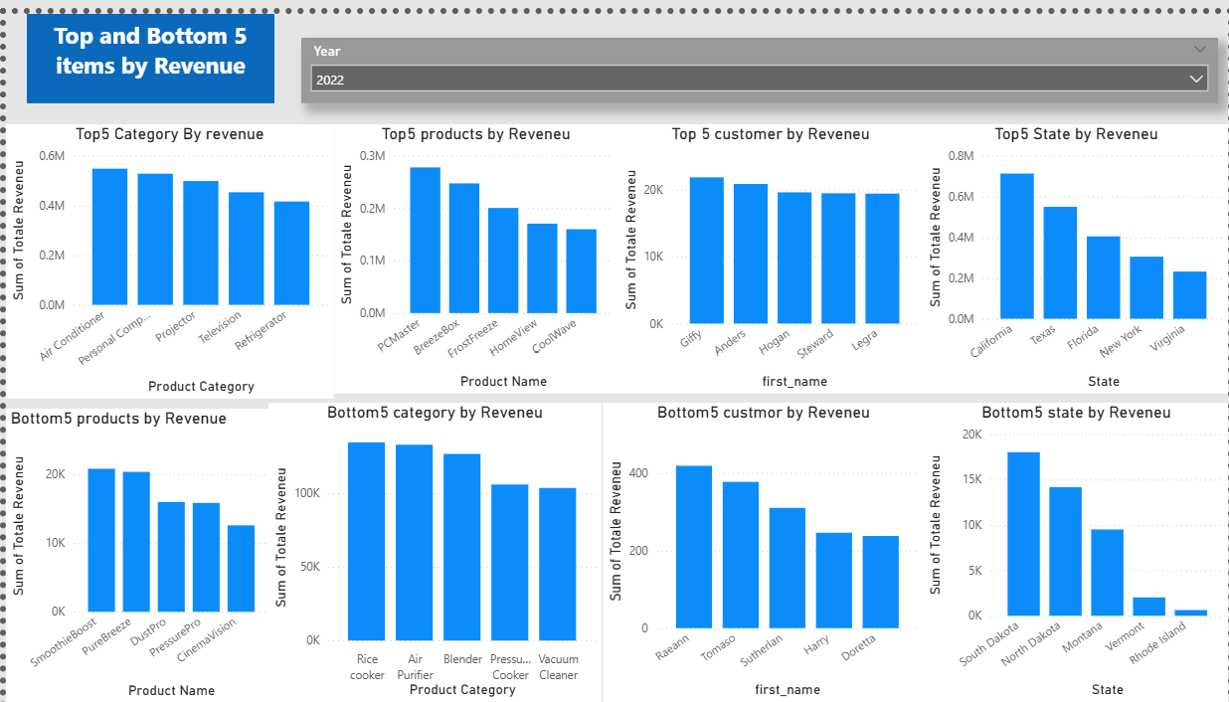
9. Products Influencing Total Revenue
This section focuses on identifying products with the greatest impact on overall revenue. A small number of high-impact products often contribute a significant share of total sales, highlighting the importance of protecting and strategically managing these key revenue drivers.

10. Customer Analysis
Customer trends over the five-year period provide insight into market growth and stability. Changes in customer numbers are analysed alongside revenue to understand whether growth is driven by increased customer volume, higher spending, or both.

11. Interactive Q&A and User Exploration
The report includes a Q&A feature that allows users to ask natural language questions about the data. This enhances accessibility for non-technical stakeholders and supports self-service analytics without requiring advanced Power BI knowledge.

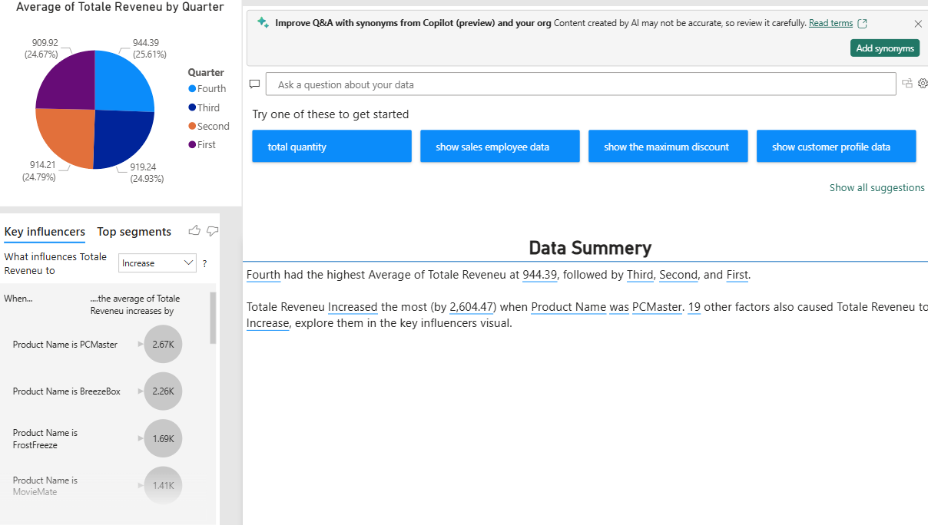
12. Key Insights and Findings
- Revenue shows clear variation across years and quarters, indicating seasonality
- A small number of products and categories drive a large proportion of total revenue
- Employee performance varies significantly, highlighting opportunities for targeted sales enablement
- Geographic performance is uneven, with certain states consistently more profitable

13. Conclusion
This five-year sales performance analysis provides a clear, data-driven understanding of business performance across multiple dimensions. The Power BI visualisations support strategic decision-making by enabling users to explore trends, identify strengths and weaknesses, and ask ad-hoc questions.
Overall, the report demonstrates how interactive data visualisation can transform raw sales data into meaningful business insights, aligning closely with the client’s reporting requirements for this capstone project.

